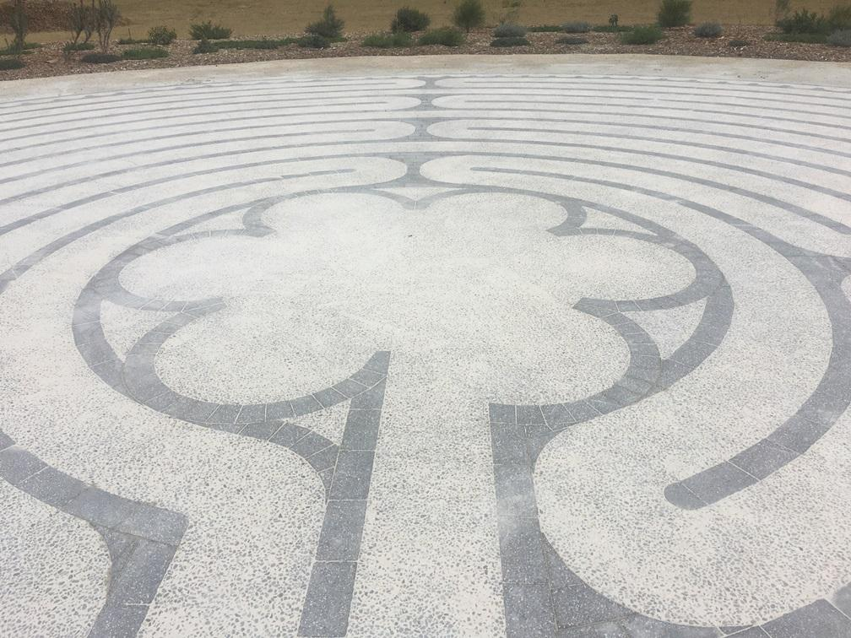
Labyrinths: where from & where to? – a self-guided inquiry
This hyperdoc can be used individually or in groups of 4 to facilitate further understanding of labyrinths. When used with a group of 4, allocate one question section/participant and each takes responsibility for sharing their respective findings with the others
Begin by walking a finger labyrinth or any available labyrinth – indoors or outdoors.
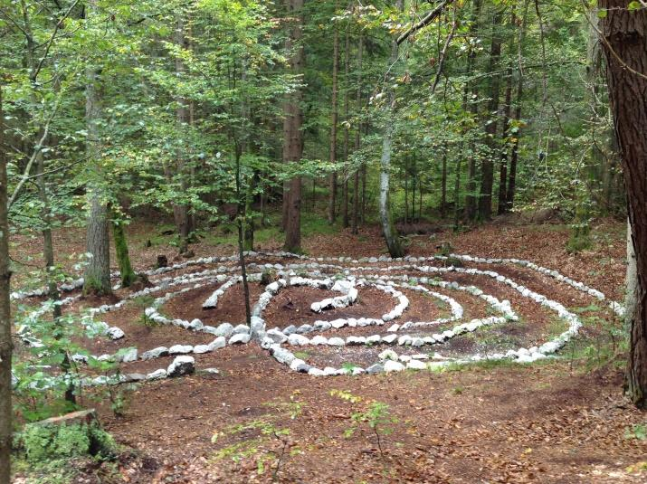 | What is a labyrinth?  What is a labyrinth not?  How does labyrinth terminology work?  https://labyrinthsociety.org/about-labyrinths  http://www.relax4life.com/wp-content/uploads/2017/11/What-Is-A-Labyrinth-9-13-.pdf
Where have labyrinths come from?  What is the earliest known labyrinth?  http://www.labyrinthos.net/Labyrinth%20Typology.pdf  http://www.labyrinthos.net/First%20Labyrinths.pdf | 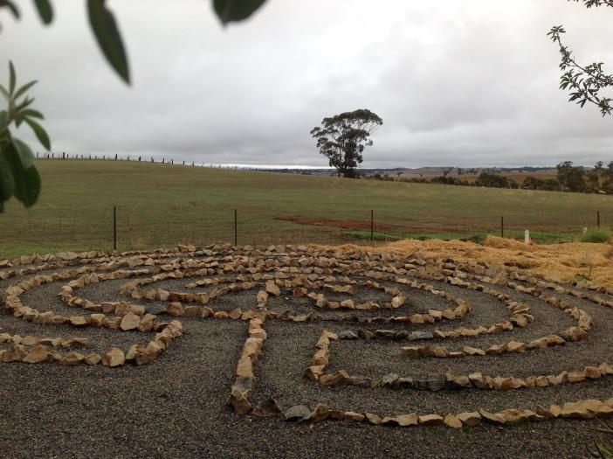
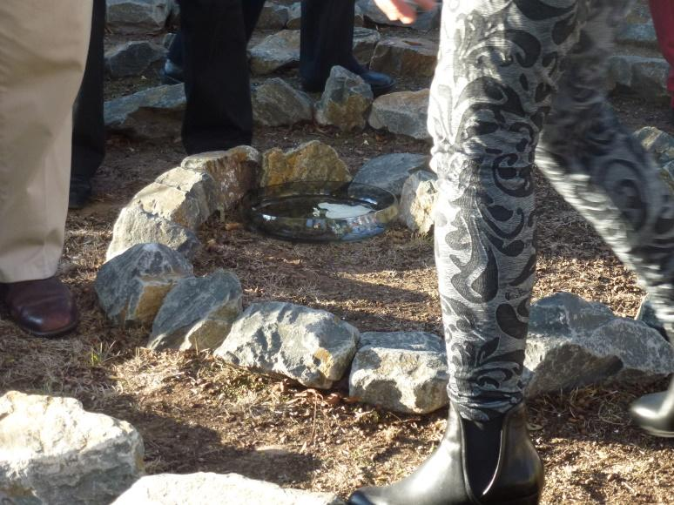 | How are labyrinths used?  https://www.veriditas.org/New-to-the-Labyrinth  http://lessons4living.com/101%20Ways%20Labyrinth.PDF  http://www.peacelabyrinth.org/how-to-walk-the-labyrinth
Where are labyrinths found today?  https://labyrinthsociety.org/labyrinths-in-places | 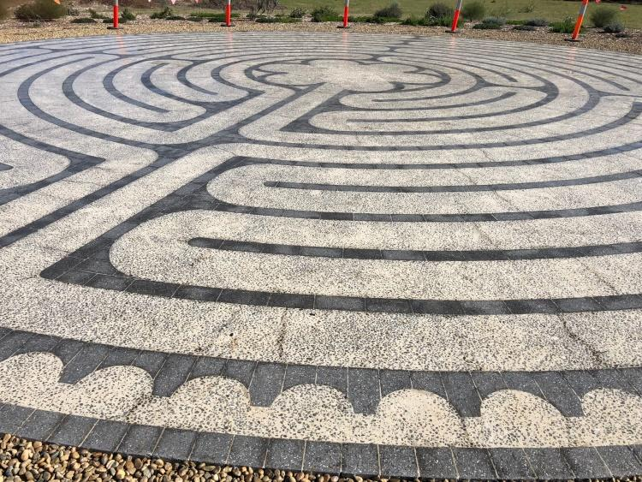

“Throughout the long history of labyrinths whenever and wherever society is going through rapid change and development the labyrinth has blossomed. Now, humanity is seeking the sure path of the labyrinth in an uncertain and confusing world.” ~ Jeff Saward, Labyrinth Historian

“Walking the labyrinth is not a high risk activity.” ~ Lauren Artress

