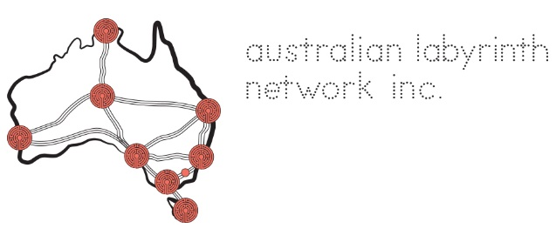

AGM 2022 Saturday 26 March 7:30 -9:00 pm AEST (Zoom)

Agenda
Attendees:
Apologies received: Madonna Rigoni
Meeting started

Acknowledgment of Country & Welcome to Attendees and introduce Immanuel as Returning Officer

Acceptance of minutes from AGM 2021
Moved: Seconded:
Chair's report (see ALN Management> ALN Meetings & Documents)

Key points
Treasurer's report (see ALN Management> ALN Meetings & Documents)

Comments

Acknowledgement of council carriers stepping down
Election
Immanuel Creagh took on the role of Returning Officer. The results of the election were xx members elected onto Council:
Chair:
Vice-Chair:
Secretary:
Treasurer:
Ordinary Members:

New Chair's address
Meeting closed

