What is Lent anyways ?
“Lent, the forty days in the Christian year that leads up to Easter, is a valuable time for Christians. The word “Lent” comes from a variety of Anglo-Saxon and Germanic words meaning “Spring”. For Christians, Lent is not a celebration of nature; rather, it is a process of prayer and spiritual renewal looking to a time budding with new spiritual life and hope. The Lenten season is an opportunity to cultivate the interior life through spiritual exercises and practices.
Rather than being seen as a “forty day endurance test”or a bleak and restricted time, Lent is a quality season. It is a time of rediscovery, a golden chance to open ourselves more deeply to the beauty and power of the dying and rising of new life in Jesus. It is a time to ponder the reality of His death and resurrection and to allow this to soak into our deepest parts.”
[From the Anglican Fellowship of Prayer Canada Pamphlet PG-34 (November 2003) “Keeping a Holy Lent”]
THIS LENT:
As the COVID Crisis still spasmodically causes our churches and businesses to close or adapt to changing restrictions, individuals ( particularly the aged, high risk and vulnerable ) can often feel more isolated and lives and income can be disrupted and threatened …what is God calling you / us to do ? - to be His presence in y(our) family, church, workplace and community? … and to also keep a Holy Lent?
Given these unfolding events …what is God calling you to :
- go away from?
- go toward?
- keep?
- “let go” and leave behind?
- change?
INVOCATION PRAYER
“Father, open our hearts and quieten our minds so that we may more clearly see the path you would have us walk during these challenging times. Give us the courage and strength to walk where You lead. Help us walk ever closer with you and keep a Holy Lent in 2021. Amen.”

SOME LENTEN REFLECTIONS FOR YOUR WALK ( but feel free to go with what has the most energy for you at this moment ) :
Before you walk in: Stop , Pause ,Breathe Deeply 5 times …be quiet and ask God to simply come and be
with you in this time of quiet ,reflection and openness“ Come Lord Jesus - Maranatha” (Rev. 22:10) .
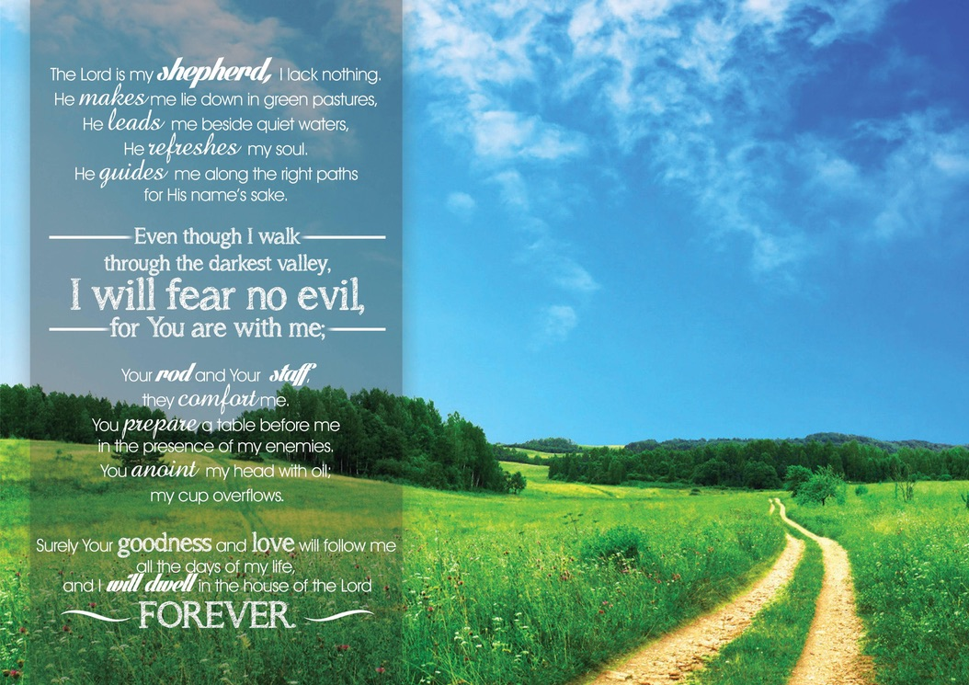
As you walk in : Given all of these unfolding events …is there a Divine invitation for you to draw closer to God ? Is there anything we need to first “let go of” / do / change / prepare/ repent … before we can explore this invitation ?

In the centre : What of ourselves ( e.g.fears, insecurities, habits, attitudes, mistakes, misjudgements, past ways of our old “normal” ) do we now need to bring to Jesus here in this sacred place to be, touched, healed and transformed …such that we can accept our Divine invitation(s) and be ready to fully welcome Jesus at Easter ?

As you walk out : How will you, with God’s grace, take your next step towards Him and accepting His invitation(s)? Are you invited to dig deeper in prayer, scripture, listening, contemplation … or perhaps you are called to action or alms giving? What needs to happen next - what is your next step?

As you leave the labyrinth: … give thanks for God for his greater willingness to be with, listen and speak with us than we are to be with, listen and pray with Him …remember that He is the one who is in control of these times and He promises to walk with us always.

CLOSING PRAYER:
“Loving God , source of healing and comfort at this time of fear, fill us with your grace that the sick may be made whole, this virus contained and a cure found. Strengthen those who care for the sick, calm the anxious and protect the most vulnerable in the power of the Spirit and in the faith of Jesus Christ our Lord”. (Source :Anglican Bishop of Grafton Dr Murray Harvey )

Jesus, thank you for being with us today, calling us ever closer to You, challenging us to adapt to these times as Your people. Sometimes we must walk alone with You but help us remember that we always, as your people, are together in your Spirit - help us make a Holy Lent.

Please also help us remember that you are with us always - as we walk out from this holy space and time into the rest of our life.

May the Grace of our Lord Jesus Christ and the love of God the Father and the fellowship of the Holy Spirit be with us all evermore . Amen .

For more information on the Anglican Labyrinth Resource Group please contact Randal or Susan Dennings on 0408 878711 / randaldennings@gmail.com.

